PIZZAS SQL QUERIES

1. KPs
2. Total Revenue

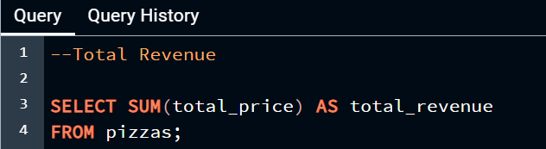

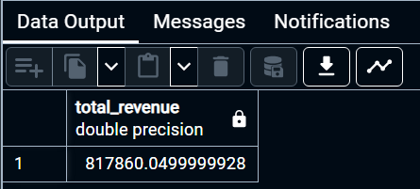

1. Average Order Value

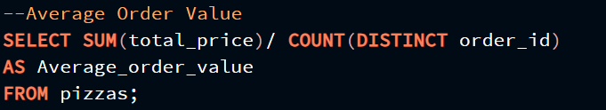

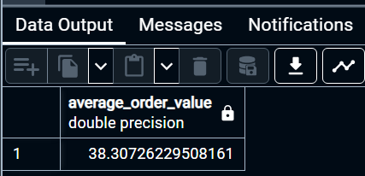

1. Total Pizzas Sold

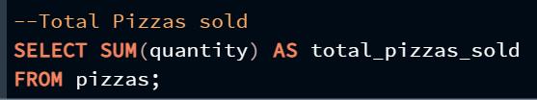

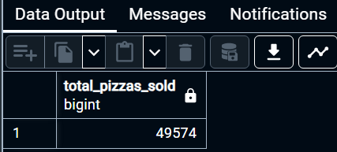

1. Total Orders

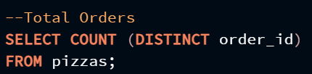

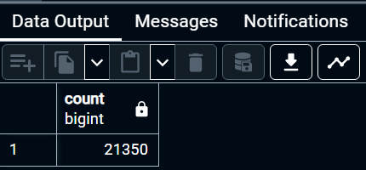

1. Average Pizzas Per Order

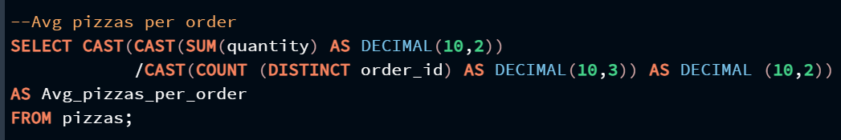

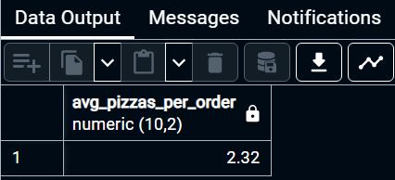

1. Daily Trend

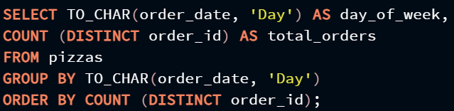

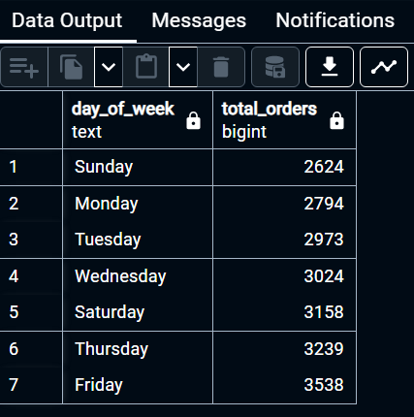

1. Hourly Trend

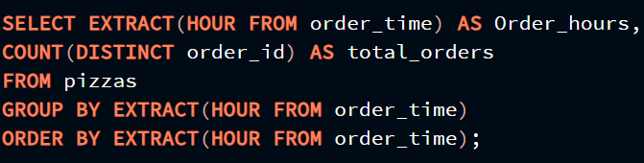

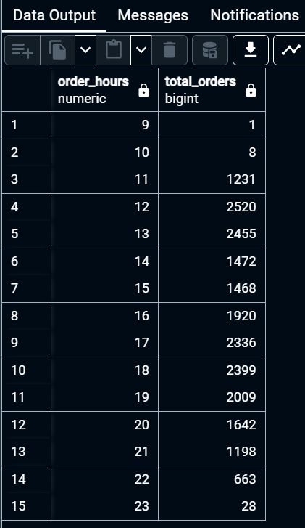

1. Percentage Of Sales By Pizza Category

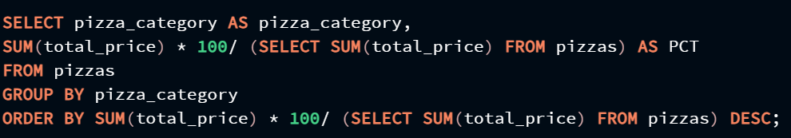

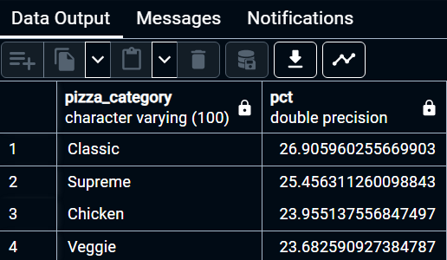

1. Percentage of Sales by Pizza Size

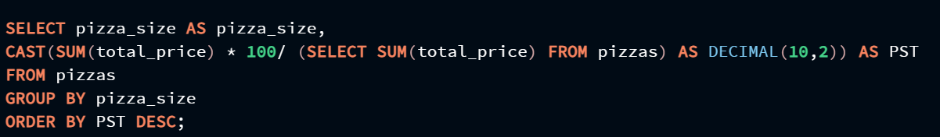

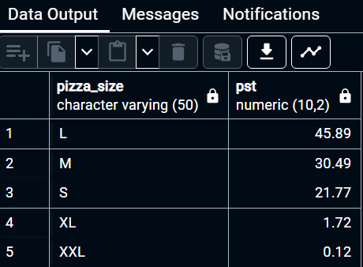

1. Total Pizzas sold by Pizzas Category

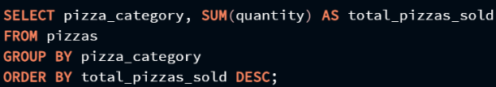

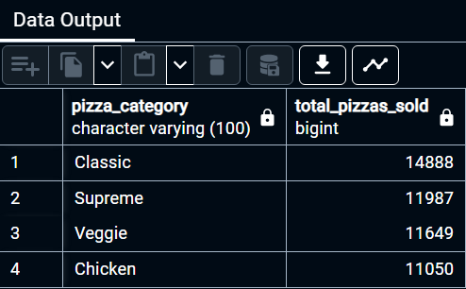

1. Top 5 Best Sellers By Total Pizzas Sold

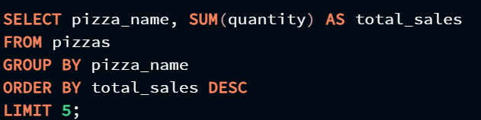

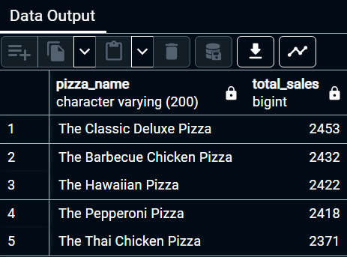

1. Bottom 5 Worst Sellers By Total Pizzas Sold

